Links
https://jab-prodcas.watc.edu:8447/cas-web/login?service=https%3A%2F%2Fmywatc.watc.edu%2Fc%2Fportal%2Flogin

https://www.bls.gov/ooh/education-training-and-library/career-and-technical-education-teachers.htm Career and Technical Education Teacher

This is Fun
Pictures

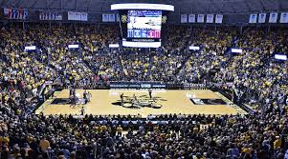

https://jab-prodcas.watc.edu:8447/cas-web/login?service=https%3A%2F%2Fmywatc.watc.edu%2Fc%2Fportal%2Flogin

https://www.bls.gov/ooh/education-training-and-library/career-and-technical-education-teachers.htm Career and Technical Education Teacher

